**KWAME NKRUMAH UNIVERSITY OF SCIENCE AND TECHNOLOGY**

**KUMASI, GHANA**

**COLLEGE OF SCIENCE, FACULTY OF BIOSCIENCES**

**DEPARTMENT OF THEORETICAL AND APPLIED BIOLOGY**

**THIS DISSERTATION IS PRESENTED TO THE**

**DEPARTMENT OF THEORETICAL AND APPLIED BIOLOGY**

**IN PARTIAL FULFILLMENT FOR THE REQUIREMENT FOR THE AWARD OF**

**BSc (Hons) DEGREE IN BIOLOGICAL SCIENCES**

**BY**

**DONKOR DEREK**

**DONKOR DEREK**

**DONKOR DEREK**

**DONKOR DEREK**

**AUGUST 2024**

**DECLARATION**

“We declare that this research has been wholly undertaken by us under the supervision of Dr. Ebenezer J. D. Belford and that except portions where references have been duly cited, this dissertation is the outcome of our research”.

DONKOR DEREK .………………………….. ..……………….......

(STUDENT) SIGNATURE DATE

DONKOR DEREK .………………………….. ..……………….......

(STUDENT) SIGNATURE DATE

DONKOR DEREK .………………………….. ..……………….......

(STUDENT) SIGNATURE DATE

DONKOR DEREK .………………………….. ..……………….......

(STUDENT) SIGNATURE DATE

DR. EBENEZER J. D. BELFORD .………………………….. ..……………….......

(SUPERVISOR) SIGNATURE DATE

# DEDICATION

This research is dedicated to the Almighty God for giving us life and seeing us through all of our educational pursuit, to our supervisor, Dr. Ebenezer J. D. Belford and to our lovely parents who have been our strength in times of difficulties and weaknesses, who made this project a success and also to our colleagues who assisted as with information.

# ACKNOWLEDGEMENT

Our special thanks goes to the Almighty God for His grace, mercies and favor in carrying out this project work. We are very much indebted our supervisor, Dr. Ebenezer J. D. Belford who actually showed much concern in the study, gave us the necessary encouragement, guidance, corrections and the invaluable suggestions which actually made this project work a success. Also, to the Council of Scientific and Industrial Research (CSIR) for their innumerable contributions.

We are grateful to all Lecturers, our field supervisor, Dr. Michael Kwabena Osei and Mr. Gyau of Horticulture Division of CSIR-CRI, Kwadaso whose immeasurable assistance cannot be forgotten, Laboratory technician especially Mr. Acheampong and fellow course mates of Biological Science Department for their innumerable assistance in diverse ways.

Finally, we sincerely appreciate our dear and loving parents for their support in every aspect not forgetting their words of encouragement. Also, to our siblings for their constant love, care, support, encouragement and prayers.

# ABSTRACT

TABLE OF CONTENS

DECLARATION ii

DEDICATION iii

ACKNOWLEDGEMENT iv

ABSTRACT v

TABLE OF CONTENS vi

LIST OF TABLES viii

LIST OF FIGURES ix

LIST OF PLATES x

LIST OF ABBREVIATION xi

CHAPTER ONE (1) 1

1.0 INTRODUCTION 1

1.1 Background 1

1.2 Investigation 2

1.3 Problem Statement 3

1.4 Justification of the Study 3

1.5 Importance of fish study 4

1.6 Objectives 5

1.6.1 Main objective 5

1.6.2 Specific objectives 5

CHAPTER TWO (2) 6

2. LITERATURE REVIEW 6

2.2 Identifying various fish species in rivers 6

2.2.1 Habitat and distribution 6

2.2.2 Fish species identification 7

2.3 Fish conservation Management 8

2.4 Factors that influence fish distribution 8

2.4.1 Physical factors 8

2.4.2 Biological factors 9

2.4.3 Chemical factors 9

2.4.4 Hydrological factors 10

2.4.5 Anthropogenic factors 10

2.4.6 Impacts of urbanization on river ecosystems 11

2.4.7 Fish as bio indicators of water quality 12

2.4.8 Methodologies for assessing fish diversity and distribution 13

CHAPTER THERE (3) 21

3.0. MATERIALS AND METHODS 21

3.1. Introduction 21

3.2 Research approach 21

3.3 Study area 21

3.4 Enironmental survey 22

3.4.1 Upstream 22

3.4.2 Midstream 23

3.4.3 Downstream 24

3.5 Materials and methods 25

3.5.1 Materials 25

3.5.2 Sampling procedure 26

3.5.3 Physio-chemical parameters 26

3.5.3.1 Temperature 26

3.5.3.2 Current 26

3.5.3.3 Water depth 26

3.5.3.3.1 Materials 26

3.5.3.3.2 Procedure 27

3.5.3.4 Velocity 27

3.5.3.4.1 Materials 27

3.5.3.4.2 Procedure 27

3.5.3.5 Water discharge 27

3.5.3.6 Water color 28

3.5.3.7Turbidity 29

3.5.3.8 Dissolved Oxygen 30

3.5.3.9Conductivity 30

3.5.3.10 Hydrogen ion concentration (Ph) 31

3.5.3.11 Total nitrate and phosphate 31

PREAMBLE 31

3.5.3.11.1 Total nitrate 32

3.5.3.11.2 Total phosphate 33

3.5.3.12 Fish diversity and distribution 34

3.6 Data analysis 35

CHAPTER FOUR (4) 36

# LIST OF TABLES

No table of figures entries found.

# LIST OF FIGURES

Figure 1: River Wiwi and other streams that drain the Kumasi Metropolis 22

Figure 2: Upstream of River Wiwi 23

Figure 3: Midstream of river Wiwi 24

Figure 4: Downstream of River Wiwi 25

Figure 5: Hackman multi-parameter probe 28

Figure 6: The turbidimeter reading flask 29

Figure 7: Portable turbidimeter 30

Figure 8: A spectrophotometer 32

Figure 9: Nitrate pillows 33

Figure 10: Phosphate pillow 34

# LIST OF PLATES

**No table of figures entries found.**

# LIST OF ABBREVIATION

|  |  |
| --- | --- |
| **DEKD** | **DEREK E.K. DONKOR** |
|  |  |
|  |  |
|  |  |
|  |  |
|  |  |
|  |  |
|  |  |
|  |  |

# CHAPTER ONE (1)

## **INTRODUCTION**

### **1.1 Background**

A river is a lotic water body that habours a large number of aquatic organisms including different species of fish and other organisms. The life of humans partly depend on the presence of aquatic organisms which are present in rivers. The conservation and preservation of organisms in the river can serve as a great source of protein. River ecosystem contributes to the diversity of fishes. A river is divided into three streams namely upstream, midstream and downstream. Upstream is a section of the river where the water is flowing from. Midstream is the section of the river in which water flows between upstream and downstream and downstream describes the river’s flow in the opposite direction of the upstream.

Different fish species in the river have their ecological roles by maintaining ecological balance and some fish species act as indicators of water quality. The different species in river include, tilapia, mudfish, catfish, herring, Nile perch and others, and they play important roles in the river ecosystem by feeding on algae, helping to maintain water quality (Agyekum et al 2016)

Fish species also have specific habitats inside the river ecosystem in which some factors influence them to stay. Some species prefer oxygen-rich and fast flowing areas in the river. Others also prefer deeper parts and slow moving areas in the river. Some various factors that influence the distribution of fish species inside the river are current, depth, temperature, food availability, shelter, Ph, dissolved oxygen and other factors. Fishes in the rivers often move to the upstream to search for food, breeding or even migration. Some move to midstream to avoid strong currents. Other fishes move to downstream to escape unfavorable conditions from upstream and midstream.

This study investigates the diversity and distribution of fishes in the Wiwi River, Kumasi, Ghana. It studies how fishes are diverse in the Wiwi River, richness and abundance, how the fishes are distributed inside the river and the various factors that influence their distribution. This will contribute to a greater understanding of the biodiversity of rivers and conservation efforts. Additionally, it would help with improved river management, ensuring that this priceless natural resource is preserved for the benefit of the local community.

The flow of river is in one direction thus, is unidirectional. The lotic nature of rivers has rendered it to be organized in a horizontal direction. Recent study suggests that rivers hold less than 2% of fresh water bodies. The diversity and distribution of fishes present in rivers vary greatly, this can be due to factors such as climate changes and so on. The diversity of fish species which encompasses species richness and species evenness also varies depending on the type of fish species. Also, the distribution of fishes is mainly detected by temperature. Majority of fishes are found at warmer areas.

The study of fishes is known as itchyology, and fishes are known to be paraphyletic thus, is one that includes a common ancestor and some of it’s descendants but not all.

Many factors come to play with diversity of fishes. Some of the criteria for identifying the type of fish species includes; the position of the fins, the type of scale present, mode of respiration and so on.

There are various types of scales when it comes to the type of fish species. The placoid scale which is also known as the dermal denticles can be used as a basis to identify the type of fish species present. This scale can be used to the determine the age of the fish. It does not grow with the fish rather, the new scales grow between the old scales. This type of scale is mostly seen in sharks and rays. Another forms of scales include cosmoid scale which evolved from placoid scale, is mostly seen in lung fishes. Ctenoid and cycloid scales are another form of scales which are collectively known as elasmoid scales. One special feature of the elasmoid scale is it’s prominent nature. Last but not the lest, is the the ganoid scale which also evolved from the cosmoid scale. There are two layers which includes the dentine layer and the ganoine layer. Another criteria for identifying fishes is extraction of oxygen , some fishes use their lungs, intestine, labyrinth( specialized gills) for respiration.

Fish renders high quality of nutrition to humans and other predators such as crocodiles. The fish liver is a great source of vitamin A and Vitamin D ( Retinol and Calciferol). Fishes also serves as a good source of omega 3 – fatty acids ( SMASH).

**1.2 Investigation**

Analyzing fish species diversity and distribution within the Wiwi river is the goal of this study. Our goal is to comprehend the ecological dynamics of fish populations in this river habitat by using a variety of sampling strategies and statistical studies. To give a thorough picture of the organization of the fish community, the study includes habitat evaluations, species identification, and population estimates.

**1.3 Problem Statement**

River Wiwi is a small stream passing through the Kumasi Metropolitan Area in Ghana, draining a catchment area of approximately 276 km2 (Darko *et al*, 2022). As one of the very few perennial rivers in the otherwise semi-arid Ashanti Region landscape, River Wiwi provides vital ecological, economic and socio-cultural services locally (Abban et al., 2016; Amevenku *et al*., 2020). In its upper reaches, the Wiwi remains largely unimpacted by Kumasi's sprawl.  The ecological health of River Wiwi in Kumasi, Ghana is of great importance to the local communities who rely on the river for their livelihoods. The current understanding of fish diversity and distribution in Wiwi is minimal, interfering effective management and conservation efforts. The river is facing multiple anthropogenic pressures, including pollution, overfishing, and habitat degradation, which are likely to have negative impacts on the fish populations. The absence of complete data regarding the distribution, abundance, and habitat preferences of different fish species poses a threat to the long-term health of the river and hinders the establishment of sustainable fisheries management methods(Phillipson_and_Symes_2013). Therefore in addressing this problem, it is important to determine the species richness and abundance of fish in Wiwi, analyze the factors influencing their distribution, and assess the impact of environmental variables on fish diversity in the river.

**1.4 Justification of the Study**

Rivers are complex ecosystems that support a diverse array of fish species. Documenting the fish species present in River Wiwi can contribute to understanding the biodiversity of the region and provide a baseline for monitoring changes over time. Understanding the distribution patterns and abundance of different fish species can inform conservation efforts and aid in the development of effective management strategies for the river ecosystem. This information can help identify threatened or endangered species, as well as areas that require special protection or restoration efforts. Moreover, Fish are often used as bioindicators of water quality and ecosystem health. Studying the fish community can reveal important information about the overall health of the river ecosystem and potential impacts from human activities, such as pollution, habitat degradation, or overexploitation(Naigaga *et al*, 2011).

Investigating the fish species composition and distribution patterns can provide valuable data for ecological research. This information can contribute to understanding factors that influence fish community structure, such as habitat preferences, interspecific interactions, and environmental conditions. Conducting a comprehensive study of the fish community in River Wiwi can establish a baseline dataset for future monitoring and comparison. This baseline can be used to detect changes over time, assess the effectiveness of management interventions, and identify emerging threats or impacts. Finally, studying the fish community in River Wiwi can contribute to the broader scientific understanding of freshwater ecosystems, species distributions, and ecological processes, particularly if the river system possesses unique characteristics or supports understudied species.

### **1.5 Importance of fish study**

1. Water quality: fish serve as sensitive indicator of environmental health, this make them important in monitoring water quality, pollution level and other environmental issues ( Doudoroff et al.,1957).
2. Economic value: Fish serve as a major source of food and income for millions of people in the world, fish studies can help to understand how fish populations are affected by various stressors, overfishing, habitat loss and develop sustainable fishing practice (*Lynch et at.,2017*
3. Disease control: Studies on fish can lead to detailed understanding and description of diseases such as symptoms and their causes. These contribute to effective treatment and preventive measures to manage and control fish diseases.( *Edward et al.,2010).*
4. Biodiversity conservation: Fish studies can help to accurately classify and describe fish species, the evolutionary relationships among different fish species and their roles in ecosystem which is essential for preserving biodiversity and maintaining a healthy aquatic ecosystem ( *Roberto et al.,2016).*

### **1.6 Objectives**

#### **1.6.1 Main objective**

The aim of the study is to examine fish diversity and distribution in river Wiwi in Kumasi, Ghana

#### **1.6.2 Specific objectives**

The study seek to achieve the following specific objectives

1. Determine the various fish species present in river Wiwi
2. Analyze the relative abundance and distribution patterns of catfish species in river Wiwi
3. To determine the physiochemical parameters of Wiwi River in Kumasi, Ghana.

# CHAPTER TWO (2)

## **2. LITERATURE REVIEW**

2.1 Historical overview of fish diversity and distribution

Fishes have developed into a vast array of species over millions of years, occupying a variety of habitats and conditions. Fishes have a remarkable evolutionary history that attest to their adaptability and tenacity, from the jawless fish of prehistoric times to the wide variety of fish we see today. Fish population vary widely throughout the world due to a variety of factors including habitat availability, climate change and other factors. This helps to understand how aquatic ecosystems are interconnected and how changes in the environment affect the diversity and distribution of different fish species. There are ecological factors affecting fish diversity and some of these factors include environmental changes such as habitat alterations, water pollution, climate change and overfishing (Attipoe et al 2017). The distribution of fishes also have factors influencing them. Factors like temperature of the river, depth, flow rate and anthropogenic activities like pollution ( Ofori-Danson et al 2015).

### 2.2 Identifying various fish species in rivers

#### 2.2.1 Habitat and distribution

Fish habitat and distribution is essential for preservation of fish populations and their ecosystems in the field of aquatic ecology. Fish habitat describes the specific conditions that allow particular species of fish to live in specific aquatic environment. Fish distribution describes where different species of fish are found inside the river. The habitat and distribution of fish species in rivers are influenced by various environmental factors. The physical characteristics of river habitats such as water flow, depth and substrate are important factors influencing fish habitats and distributions (Gebrekiros 2016). With the water flow, every species of fish in a river have adapted to different types of currents. The gradient of the river, the amount of water in it and the presence of obstructions can affect the water flow. While certain fishes like catfish may seek out slower or calmer spots along the riverbanks, others like trout may favor swiftly moving oxygen-rich water.

The depth of the river also influence fish habitat and distribution. Different species have specific depths based on factors like food availability, temperature and shelter. Fishes like catfish normally prefer deeper, calmer areas in the main channel. Substrates are materials at the bottom of river where fishes live and also find food. There are substrates like gravels or sand bottom, rocky areas or vegetation. The type of substrate influences the fish species present in the particular river habitat. Threats to freshwater fish in rivers affect fish habitat and distribution. Threats like habitat degradation (deforestation) negatively affect fish habitat and distribution. Pollution, climate change, overfishing and invasive species are all threats that negatively affect fish habitat and distribution (Wang et el, 2020).

#### 2.2.2 Fish species identification

Fish species identification involves the combination of methods to accurately identify different species of fish in a river. The methods include morphometric, meristic, anatomical and molecular identifications. Morphometric identification involves measuring the body of the fish to determine the type of fish species. This include measuring the distance from the tip of the snout to the base of the caudal fin, the maximum height of the fish’s body, the total length of the fish, etc. Meristic identification includes counting specific body parts of the fish such as the scales and fins. The number of scales along the lateral line from the head to the base of the caudal fin is counted and the number of fin rays in the dorsal, pectoral, pelvic, anal and caudal fins are also counted. Anatomical identification comprises the overall shape of the fish’s body including its length, height, and width. It also comprises the number, shape and position of the fins and shape, size and texture of the scales to identify the type of fish (R. Froese and D.Pauly,2019). There has been advancements in the methods of fish species identification which have also significantly contributed to the accuracy and efficiency of ecological assessments (molecular identification). DNA based technique like environmental DNA (eDNA) metabarcoding is one of the modern techniques for identification of fish species. eDNA metabarcoding is a powerful tool that is used to identify various fish species through DNA sequencing. Water samples are used to identify fish species. Specific DNA regions are targeted for this analysis although it has advantages and disadvantages. One advantage is that, in a situation where the fish is not directly observed, e DNA, can be used to identify its presence in the river and it is due to the fact that even after the fish has vanished, e DNA can linger in the environment for a longer period. It can also be used to check fish abundance by calculating the amount of e DNA present in the river sample which is equal to the number of fish species. But the challenge in e DNA is that environmental factors like temperature and sunlight can break down e DNA and since it is mostly found in the river in small amounts, gathering enough e DNA for analysis might be challenging. ( Deiner, k et al. 2017).

### 2.3 Fish conservation Management

Fish conservation works to maintain the long term survival of fish species and the quality of aquatic habitats by controlling variables such as pollution, habitat degradation, overfishing and climate change. Conservation management also entails researching fish behavior and ecosystems and also interacting with local communities. Different approaches have been taken to safeguard fish species, their habitats and biodiversity in general. Some of the approaches are enforcing laws to restrict fishing and safeguard fish population, establishing protected areas to offer fish safe havens and restoring damaged habitats to enhance water quality and supply fish with vital resources (FAO, 2018).

### 2.4 Factors that influence fish distribution

Fish distribution can be influenced by a variety of factors, which can be grouped into physical, biological, chemical, hydrological and anthropogenic factors.

#### 2.4.1 Physical factors

The physical factors include current, temperature and substrate.

Current: This factor influences the distribution of fishes in several ways. In order to locate food, several fish species migrate up and down rivers. The success of these migrations can be influenced by rivers current. For instance, if the river is too strong, certain fish species might not be able to move upstream. How fishes feed can also be influenced by current. Certain fish species might eat plankton and other microscopic creatures that the current carries. (Ofori- Danson, E.H.K Akahoho and SKD Adjei, 2020).

Temperature: One of the most significant factors influencing fish distribution is temperature. The distribution of fish species is imparted by the water temperature in the various locations of the river since different fish species have varying temperature tolerances. Certain fish species like salmon have evolved to survive in cold water because the water is colder (10-15 degrees) in the upper portion of the river and fish species like catsfish have evolved to survive in warm (24-30 degrees) environment in the river so it is usually found in the lower parts of the river. (Ofori-Danson, E.H.K Akahoho and SKD Adjei, 2019)

Substrate: Substrate is a type of materials that forms the bottom of a river. It mostly consist of boulders, sand, gravels, bedrock and other things. The distribution of fish species in a river can be influenced by the kind of substrate especially in choosing a habitat. Different kinds of substrates are preferred by different fish species. Salmon for instance prefer living in environment with gravels, catfish prefer living in environment with muddy substrates and tilapia prefer living in environment with substrates of sand and gravels.

#### 2.4.2 Biological factors

Competition: Competition arise is when two or more fish species utilize the same resources such as food, habitat or spawning sites. Competition may cause one or more fish species to become extinct from a portion of the river. Some fish species might be able to avoid competition with one another because of their more specialized diets or habitat needs.

Predation: When one animal (the predator) kills and consumes another animal specifically fish species (prey), it is known as predation. Fishes are preyed upon by a variety of animals including birds, mammals, reptiles and other fishes. Certain fish species might be more susceptible to predators than others. Fishes that in shallow water or close to riverbanks are more likely to be eaten by birds and other animals. By residing in deeper water or hiding behind vegetation, some fish species could be able to avoid predators.

#### 2.4.3 Chemical factors

Ph: Ph is a measure of acidity or alkalinity of a river. It ranges from 0-14. Some fish species are able to tolerate acidity or alkalinity in the river than others. Some can tolerate Ph as low as 4.0 and others tolerate ph as high as 7.0 or more to survive. Tilapia can tolerate wider ph than catfish with ph level as low as 4.0 and as high as 10.0. Catfish are more sensitive to changes in ph and tolerate changes between 6.5 and 8.0.

Dissolved oxygen: Fishes need dissolved oxygen to respire. The cold, fast flowing areas of the river have higher dissolved oxygen than the areas with warm, slow flowing rivers. Pollutants like sewage can reduce the levels of dissolved oxygen in a river. Catfish are mostly found in warm, slow flowing areas with lower levels of dissolved oxygen.(Allan J.D, 2004)

Conductivity: Conductivity is often higher in rivers that are polluted with salt and other ions. It is also lower in rivers that are not polluted. Different fish species in the river are distributed according to their conductivity levels. Catfish are mostly found in rivers with high levels of conductivity (Dodds W.K, 2002)

#### 2.4.4 Hydrological factors

The hydrological factors include both physical and chemical changes in the water that can influence the distribution of fish.

Nutrient availability: The availability of nutrients such as nitrogen and phosphorus can influence fish distribution. Some fish species are found in areas with high availability of nutrients while others are found in areas with low nutrient availability. Some fishes prefer areas with high nitrate availability and low phosphate availability and vice versa.

Depth: The depth of the river influences fish distribution. Some fish species are found in the deepest part of rivers while others are found in the shallow areas.

#### 2.4.5 Anthropogenic factors

These include human activities such as overfishing, urbanization, agricultural and industrialization which causes pollution and excessive nutrients into the river. Climate change is also an anthropogenic factor since it is primarily caused by human activities. Anthropogenic factors can have significant impacts on fish distribution, altering the structure and functions of these ecosystems.

Pollution: This can degrade fish habitats by destroying water quality, reducing levels of dissolved oxygen and increasing sediment loads which can affect the survival of fishes, their reproduction rate and also food availability. ( A study in the journal, “Science of the Total Environment”,2022)

Overfishing: This reduces the abundance of fishes in the river which can result in fish distribution as the fishes move to areas with low fishing pressure and high availability of food.

Understanding all these factors is very important for managing and conserving aquatic ecosystems.

#### 2.4.6 Impacts of urbanization on river ecosystems

Habitat lost is the first threat to biodiversity in which urbanization play a major role in it. Development such as building of infrastructures which includes schools, factories, estates and so on. Many river bodies have now been used as dams, as a result it has led to extinction of higher percentages of aquatic organisms especially fishes. Even though certain aquatic organisms such as fishes has developed the adaptation to breathe outside water an example is the double lung fish. This mechanism of breathing outside water occurs for a few minutes hence cannot survive for a long time if not placed back into the water body. According to the Intergovernmental Science-Policy Platform on Biodiversity and Ecosystem Services (IPBES) one million (1,000,000) mammals are at risk of facing extinction of which fishes form an integral part of it because fishes account for more than half of living vertebrate.

Urbanization has had a great adverse effect on river bodies which has led to extinction of high number of fish species such as the jawed armoured fish which belongs to super class Gnathostomata under the class placodermi. With a close observation of the paraphyletic tree of fishes were agnatha (jawless fishes) evolved into Chondrichthyes (cartilaginous fishes) then to acanthodii (spiny sharks) then finally to Osteichthyes (bony fishes). Officially, class ostracodrmi (armoured jawless fishes) and class acanthodii (spiny shark) are extinct.

Some of the effect of urbanization on river bodies in pollution. Many of the river bodies today are polluted due to developmental projects. Some fishes are not able to live in a polluted river hence ends up dying or can lead to outbreak of diseases in the fish community. Certain fish species too are able to adapt to the pollution in the river body. When a river is polluted, fishes or any other aquatic organism present harbors a high percentage of this pollutant. When this happens it becomes dangerous if these fishes are eaten by people in the community.

Impacts of Urbanization on River Systems in the Taihu Region, China [MDPI journal article on urbanization’s effects on river systems in China] by Li et al. (2017) examines the specific case of the Taihu region and the ecological challenges brought on by urbanization. There are 28,000 extant fish species of which there exist 515 families and 62 orders. Bony fishes makes up 26,000 about 1000 are cartilaginous fishes and 108 are jawlwss fishes. Naturally 1 species is supposed to go extinct every 500-1000 years. But today due to urbanization more than half of every species is known to go extinct and 1 million are threatened with extinction.

#### 2.4.7 Fish as bio indicators of water quality

Freshwater ecosystem contain about 10% of the fauna species on earth and offer environmental services, however, human activities affect freshwater resources structurally and functionality, reducing the possibility of using it. Freshwaters are among the most threatened ecosystems in the world and therefore aquatic organisms require attention for their conservation. (Eugenia Lopez, J.E Sedeno Diaz et al.,2014)

Among fauna, fish are considered as effective bioindicators of water quality due to their sensitivity to environmental changes and various pollutants. Here are some reasons why fish are use as bioindicators:

Exhibit excellence signals for assessing stressors. The main approaches for assessing freshwater ecosystem can be review by using fishes. . By low organization levels biomarkers are excellent early warning indicators making evident that organisms have been in contact with contaminants and the effects can be reversible, while the high organization levels reflect an overview of the global impact. Biomarkers are the biological indicators that can be measured in fish to access their health, overall environmental conditions and exposure to pollutants. These biomarkers provide important information for fisheries management, environmental monitoring and conservation efforts.

Sensitivity to pollutants. Fish are sensitive to a wide range of pollutants, including organic contaminants, heavy metals and pesticides. Changes in fish health and behavior such as deformities and lesions; physical abnormalities can be a sign of chronic pollution, fish kill events; sudden die offs can indicate pollution events, behavioral changes; altered swimming patterns or feeding behavior can suggest sub-lethal stress from pollutants.

Diverse respond. Fish exhibit a wide range of responses to changes in water quality, making them valuable bio indicators of environmental health. Some key responses that fish can display include physiological responses: fish can show physiological responses to water quality changes such as growth and development, immune function and reproductive health. Biochemical responses: Fish can also exhibit changes in biochemical responses such as protein expression and enzyme activity. Behavioral responses fish may change their behavior in response to water quality such as swimming, feeding behavior and predator – prey interaction. Ecological responses: fish may also change their environment in response to water quality such as community structure and population dynamics.

#### 2.4.8 Methodologies for assessing fish diversity and distribution

Assessing fish diversity and distribution is important for effective conservation and management of aquatic ecosystems. There are different methods that can be employed and each of them has its strengths and weaknesses.

Visual surveys involve observing and recording fish species in their natural habitat noting their characteristics and behavior. These methods are usually used in shallow waters where visibility allows for accurate species identification and abundance estimation. This method is cost-effective and provides valuable information on fish behavior and habitat preferences (Kulbicki et al., 2010).

Active sampling which involves directly catching fish using techniques like seining, electrofishing, or netting. It’s a hands-on approach which involves actively targeting and catching fish at each site of the water including all available microhabitat (pools, riffles and runs) to study population dynamics, species composition, and habitat preferences. This method provides accurate data on fish abundance and biomass (Fisher et al., 2015).

Passive sampling which involves using devices such as remote underwater cameras or acoustic sensors to monitor fish populations without actively capturing (Harvey et al., 2012). Fishes can be counted across the entire width of the river using single or multiple observers depending on the river’s width and visibility. Observations can be also be made along known transects of known length and width. (Pratt, 2004; Buckland et al. 1993). This method of direct observation tends to minimize harm to the fishes especially when working on endangered populations (Nielsen 1998)

Genetic Analysis to identify fish species is mostly by genomic methods. Various DNA-based methods are used for fish species identification. The Fish Barcode of Life Initiative (FISH-BOL), a global effort to coordinate and standardize a reference sequence library for fish species, aimed to create a reliable, fast and cost-effective way to identify fish species based on DNA analysis(Swartz et al). Genetic analysis can be used to identify fish species and assess genetic diversity (Ward et al., 2009).

Acoustic Telemetry method which also involves tracking fish movements using acoustic transmitters and receivers (Heupel et al., 2006). The methods include morphological identification, which involves studying accurately the physical characteristics like body shape of fishes, fins structures and scale patterns and using morphometric and meristic analysis which involve measuring the physical dimensions of fish (length, width, fin size of fish) and counting specific repeatable traits in fish (number of scales often along the lateral line, number of gill rakers) respectively (R. Froese and D. Pauly, 2019)

**2.4 Factors that influence fish distribution**

Fish distribution can be influenced by a variety of factors, which can be grouped into physical, biological, chemical, hydrological and anthropogenic factors.

**2.4.1 Physical factors**

The physical factors include current, temperature and substrate.

Current: This factor influences the distribution of fishes in several ways. In order to locate food, several fish species migrate up and down rivers. The success of these migrations can be influenced by river’s current. For instance, if the river is too strong, certain fish species might not be able to move upstream. How fishes feed can also be influenced by current. Certain fish species might eat plankton and other microscopic creatures that the current carries. (Ofori- Danson, E.H.K Akahoho and SKD Adjei, 2020).

Temperature: One of the most significant factors influencing fish distribution is temperature. The distribution of fish species is imparted by the water temperature in the various locations of the river since different fish species have varying temperature tolerances. Certain fish species like salmon have evolved to survive in cold water because the water is colder (10-15 degrees) in the upper portion of the river and fish species like catsfish have evolved to survive in warm (24-30 degrees) environment in the river so it is usually found in the lower parts of the river. (Ofori-Danson, E.H.K Akahoho and SKD Adjei, 2019)

Substrate: Substrate is a type of materials that forms the bottom of a river. It mostly consist of boulders, sand, gravels, bedrock and other things. The distribution of fish species in a river can be influenced by the kind of substrate especially in choosing a habitat. Different kinds of substrates are preferred by different fish species. Salmon for instance prefer living in environment with gravels, catfish prefer living in environment with muddy substrates and tilapia prefer living in environment with substrates of sand and gravels.

**2.4.2 Biological factors**

Competition: Competition arise is when two or more fish species utilize the same resources such as food, habitat or spawning sites. Competition may cause one or more fish species to become extinct from a portion of the river. Some fish species might be able to avoid competition with one another because of their more specialized diets or habitat needs.

Predation: When one animal (the predator) kills and consumes another animal specifically fish species (prey), it is known as predation. Fishes are preyed upon by a variety of animals including birds, mammals, reptiles and other fishes. Certain fish species might be more susceptible to predators than others. Fishes that in shallow water or close to riverbanks are more likely to be eaten by birds and other animals. By residing in deeper water or hiding behind vegetation, some fish species could be able to avoid predators.

**2.4.3 Chemical factors**

Ph: Ph is a measure of acidity or alkalinity of a river. It ranges from 0-14. Some fish species are able to tolerate acidity or alkalinity in the river than others. Some can tolerate Ph as low as 4.0 and others tolerate ph as high as 7.0 or more to survive. Tilapia can tolerate wider ph than catfish with ph level as low as 4.0 and as high as 10.0. Catfish are more sensitive to changes in ph and tolerate changes between 6.5 and 8.0.

Dissolved oxygen: Fishes need dissolved oxygen to respire. The cold, fast flowing areas of the river have higher dissolved oxygen than the areas with warm, slow flowing rivers. Pollutants like sewage can reduce the levels of dissolved oxygen in a river. Catfish are mostly found in warm, slow flowing areas with lower levels of dissolved oxygen.(Allan J.D, 2004)

Conductivity: Conductivity is often higher in rivers that are polluted with salt and other ions. It is also lower in rivers that are not polluted. Different fish species in the river are distributed according to their conductivity levels. Catfish are mostly found in rivers with high levels of conductivity (Dodds W.K, 2002)

**2.4.4 Hydrological factors**

The hydrological factors include both physical and chemical changes in the water that can influence the distribution of fish.

Nutrient availability: The availability of nutrients such as nitrogen and phosphorus can influence fish distribution. Some fish species are found in areas with high availability of nutrients while others are found in areas with low nutrient availability. Some fishes prefer areas with high nitrate availability and low phosphate availability and vice versa.

Depth: The depth of the river influences fish distribution. Some fish species are found in the deepest part of rivers while others are found in the shallow areas.

**2.4.5 Anthropogenic factors**

These include human activities such as overfishing, urbanization, agricultural and industrialization which causes pollution and excessive nutrients into the river. Climate change is also an anthropogenic factor since it is primarily caused by human activities. Anthropogenic factors can have significant impacts on fish distribution, altering the structure and functions of these ecosystems.

Pollution: This can degrade fish habitats by destroying water quality, reducing levels of dissolved oxygen and increasing sediment loads which can affect the survival of fishes, their reproduction rate and also food availability. ( A study in the journal, “Science of the Total Environment”,2022)

Overfishing: This reduces the abundance of fishes in the river which can result in fish distribution as the fishes move to areas with low fishing pressure and high availability of food.

Understanding all these factors is very important for managing and conserving aquatic ecosystems.

2.4.6 Impact of urbanisation on river ecosystems

Habitat lost is the first threat to biodiversity in which urbanization play a major role in it. Development such as building of infrastructures which includes schools, factories, estates and so on. Many river bodies have now been used as dams, as a result it has led to extinction of higher percentages of aquatic organisms especially fishes. Even though certain aquatic organisms such as fishes has developed the adaptation to breathe outside water an example is the double lung fish. This mechanism of breathing outside water occurs for a few minutes hence cannot survive for a long time if not placed back into the water body. According to the Intergovernmental Science-Policy Platform on Biodiversity and Ecosystem Services (IPBES) one million (1,000,000) mammals are at risk of facing extinction of which fishes form an integral part of it because fishes account for more than half of living vertebrate.

Urbanization has had a great adverse effect on river bodies which has led to extinction of high number of fish species such as the jawed armoured fish which belongs to super class Gnathostomata under the class placodermi. With a close observation of the paraphyletic tree of fishes were agnatha (jawless fishes) evolved into Chondrichthyes ( cartilaginous fishes) then to acanthodii (spiny sharks) then finally to Osteichthyes ( bony fishes). Offically, class ostracodrmi ( armoured jawless fishes) and class acanthodii (spiny shark) are extinct.

Some of the effect of urbanization on river bodies in pollution. Many of the river bodies today are polluted due to developmental projects. Some fishes are not able to live in a polluted river hence ends up dying or can lead to outbreak of diseases in the fish community. Certain fish species too are able to adapt to the pollution in the river body. When a river is polluted, fishes or any other aquatic organism present harbors a high percentage of this pollutant. When this happens it becomes dangerous if these fishes are eaten by people in the community.

Impacts of Urbanization on River Systems in the Taihu Region, China [MDPI journal article on urbanization's effects on river systems in China] by Li et al. (2017) examines the specific case of the Taihu region and the ecological challenges brought on by urbanization. There are 28,000 extant fish species of which there exist 515 families and 62 orders. Bony fishes makes up 26,000 about 1000 are cartilaginous fishes and 108 are jawlwss fishes. Naturally 1 species is supposed to go extinct every 500-1000 years. But today due to urbanization more than half of every species is known to go extinct and 1 million are threatened with extinction.

2.4.7 **Fish as bioindicators of water quality**

Freshwater ecosystem contain about 10% of the fauna species on earth and offer environmental services, however, human activities affect freshwater resources structurally and functionality, reducing the possibility of using it. Freshwaters are among the most threatened ecosystems in the world and therefore aquatic organisms require attention for their conservation.(*Eugenia Lopez, J.E Sedeno Diaz et al.,2014)*

Among fauna, fish are considered as effective bioindicators of water quality due to their sensitivity to environmental changes and various pollutants. Here are some reasons why fish are use as bioindicators:

Exhibit excellence signals for assessing stressors. The main approaches for assessing freshwater ecosystem can be review by using fishes. By low organization levels biomarkers are excellent early warning indicators making evident that organisms have been in contact with contaminants and the effects can be reversible, while the high organization levels reflect an overview of the global impact. Biomarkers are the biological indicators that can be measured in fish to access their health, overall environmental conditions and exposure to pollutants. These biomarkers provide important information for fisheries management, environmental monitoring and conservation efforts.

Sensitivity to pollutants. Fish are sensitive to a wide range of pollutants, including organic contaminants, heavy metals and pesticides. Changes in fish health and behavior such as deformities and lesions; physical abnormalities can be a sign of chronic pollution, fish kill events; sudden die offs can indicate pollution events, behavioral changes; altered swimming patterns or feeding behavior can suggest sub-lethal stress from pollutants.

Diverse respond. Fish exhibit a wide range of responses to changes in water quality, making them valuable bioindicators of environmental health. Some key responses that fish can display include physiological responses: fish can show physiological responses to water quality changes such as growth and development, immune function and reproductive health. Biochemical responses: Fish can also exhibit changes in biochemical responses such as protein expression and enzyme activity. Behavioral responses fish may change their behavior in response to water quality such as swimming, feeding behavior and predator – prey interaction. Ecological responses: fish may also change their environment in response to water quality such as community structure and population dynamics.

**2.4.8 Methodologies for assessing fish diversity and distribution**

Assessing fish diversity and distribution is important for effective conservation and management of aquatic ecosystems. There are different methods that can be employed and each of them has its strengths and weaknesses.

Visual surveys involve observing and recording fish species in their natural habitat noting their characteristics and behavior. These methods are usually used in shallow waters where visibility allows for accurate species identification and abundance estimation.  This method is cost-effective and provides valuable information on fish behavior and habitat preferences (Kulbicki *et al*., 2010).

Active Sampling which involves directly catching fish using techniques like seining, electrofishing, or netting. It's a hands-on approach which involves actively targeting and catching fish at each site of the water including all available microhabitat (pools, riffles and runs) to study population dynamics, species composition, and habitat preferences. This method provides accurate data on fish abundance and biomass (Fisher *et al*., 2015).

Passive Sampling which involves using devices such as remote underwater cameras or acoustic sensors to monitor fish populations without actively capturing them (Harvey *et al*., 2012). Fishes can be counted across the entire width of the river using single or multiple observers depending on the river’s width and visibility. Observations can be also be made along known transects of known length and width. (Pratt, 2004; Buckland *et al*. 1993). This method of direct observation tends to minimize harm to the fishes especially when working on endangered populations (Nielsen 1998)

 Genetic Analysis to identify fish species is mostly by genomic methods. Various DNA-based methods are used for fish species identification. The Fish Barcode of Life Initiative (FISH-BOL), a global effort to coordinate and standardize a reference sequence library for fish species, aimed to create a reliable, fast and cost-effective way to identify fish species based on DNA analysis(Swartz *et al*., n.d). Genetic analysis can be used to identify fish species and assess genetic diversity (Ward et al., 2009).

Acoustic Telemetry method which also involves tracking fish movements using acoustic transmitters and receivers (Heupel *et al*., 2006).

The methods include morphological identification, which involves studying accurately the physical characteristics like body shape of fishes, fins structures and scale patterns and using morphometric and meristic analysis which involve measuring the physical dimensions of fish (length, width, fin size of fish) and counting specific repeatable traits in fish (number of scales often along the lateral line, number of gill rakers) respectively (R. Froese and D. Pauly, 2019)

# CHAPTER THERE (3)

## **3.0. MATERIALS AND METHODS**

### **3.1. Introduction**

The study of fish diversity and distribution in the river Wiwi is an important aspect of understanding the ecological dynamics of this freshwater ecosystem. River Wiwi is one of the complex and diverse habitats that support a wide range of fish species, each with unique adaptations and roles within the food web. This study seeks to understand the number of different species present in river Wiwi and how species are spread throughout the river which is located in Kumasi the capital of Ashanti region

### **3.2 Research approach**

An experimental study that examines the physical, chemical and biological characteristics using a combination of quantitative and qualitative methods.

### **3.3 Study area**

The study was carried out in river Wiwi which is situated in Kumasi, the Ashanti region’s capital. It is part of Ghana’s semi-deciduous zone. River Wiwi which is a small river passes through few communities in Kumasi.

River Wiwi arises from Nsunyameye near Aboabo Nkwanta is the north eastern part of Kumasi in the Ashanti region of Ghana and flows in the north eastern direction. The length of the river is about 8km from the source up to the point where the river meets another stream called the Sisai river *(Sammy et al 2013).*

The river source lies at Lat.6º north of the equator and long 1º32’ east of the Meridian.At Lat. 6º 49’ North of the equator and long 1º 35’ East of the Meridian. It is about 35.5m above sea level (Sammy et al 2013). The river Wiwi provides a variety of life forms including fishes and other aquatic organisms. It is a significant source of water for several communities in Kumasi especially for those around KNUST and surroundings.

The study area was divided into a section of three(3), starting from upstream , through midstream to downstream of the river’s flow.The upstream was selected at Asunyameye near Aboabo Nkwanta and the midstream and the downstram were selected within the university based on the activities that goes on at the river.The river in the KNUST botanical garden was chosen as midstream due to less anthropogenic activities and the downstream was chosen under the bridge because there is more anthropogenic activities.

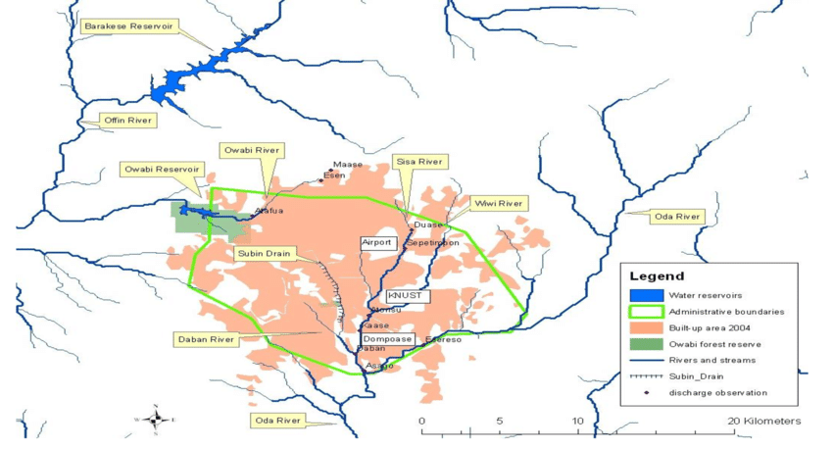

Figure 1: River Wiwi and other streams that drain the Kumasi Metropolis

### **3.4 Enironmental survey**

#### 3.4.1 Upstream

The upstream of the river Wiwi was taken at Abbirem Nkwanta in Kumasi . The colour of the river varies from time to time, there is low or no fishes present when it rains due to its dirty colour and turbulences. During the month of January to March, the river was brown in colour . But during April to May the colour of the river was very clear ,as a result high number of aquatic organisms were recorded which includes crabs, fishes and other invertebrates like tadpoles too were present. There is a lot of rocks and vegetation present at the midstream but there is also more of anthropogenic activities that goes on around the river .The temperature was recorded in the morning was 31.4º afternoon was 31.2º and evening was 32.5º. The length (L) was recorded as 55.62m, mean depth(d) was 0.5m , width(W) was 6.36m . The velocity(V) was calculated three times as 0.44, 0.423 and 0.43ms-1 , area(A) was 353.74meter square and discharge (Q) 152.462m2/s

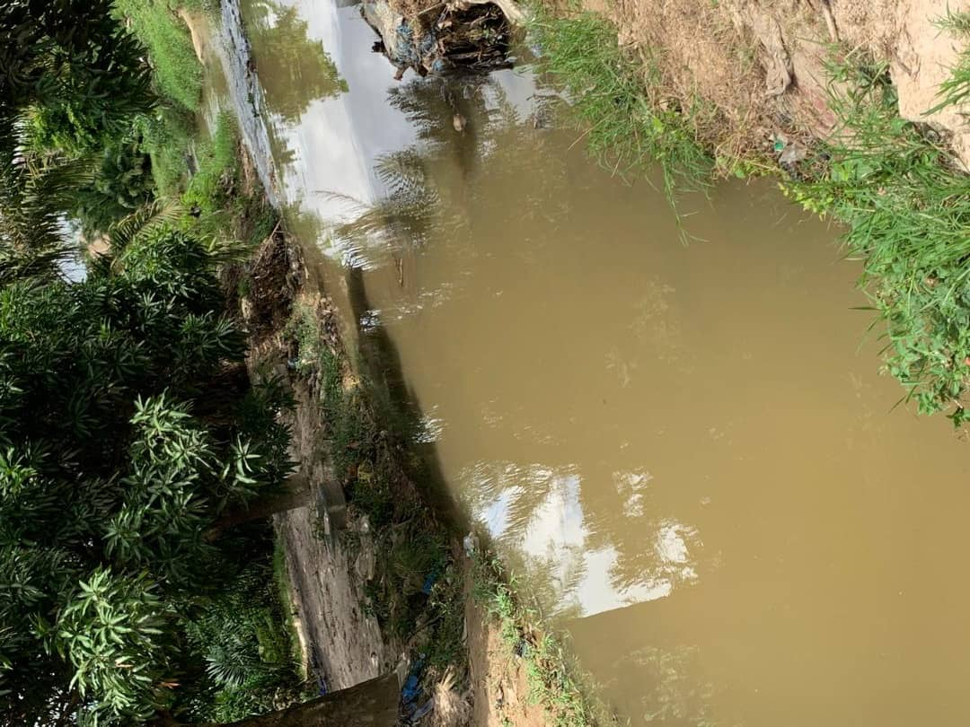

Figure 2: Upstream of River Wiwi

#### **3.4.2 Midstream**

The midstream of the river Wiwi was taken at Wiwiso located at Kumasi municipality. The clarity of the river varies depending on the season. During the month of April the colour of the river was observed to be very clear as a result a high number of fishes and other aquatic organisms were seen. But during the month of May the clarity of the water reduced , it was observed to brown in color. As a result low or no species of fish were recorded during this season. Apart of fishes, other organisms such as tadpole , chirligig bettle , crab, mosquito larva and snakes were seen. There is no or no rocks present, as a result the turbulence was low and continuous flow of the river. Temperature variation from morning , afternoon and evening were recorded as 28.1 º, 27.9º and 27.6º. The mean depth(d) was recorded as 0.627m, width(W) was 5.380m, length(L) is 43.590m. The area (A) was recorded as 234.51m2 . The velocity was calculated three times as 0.36, 0.34 and 0.38ms-1 and the discharge(Q) 84.42m2s-1

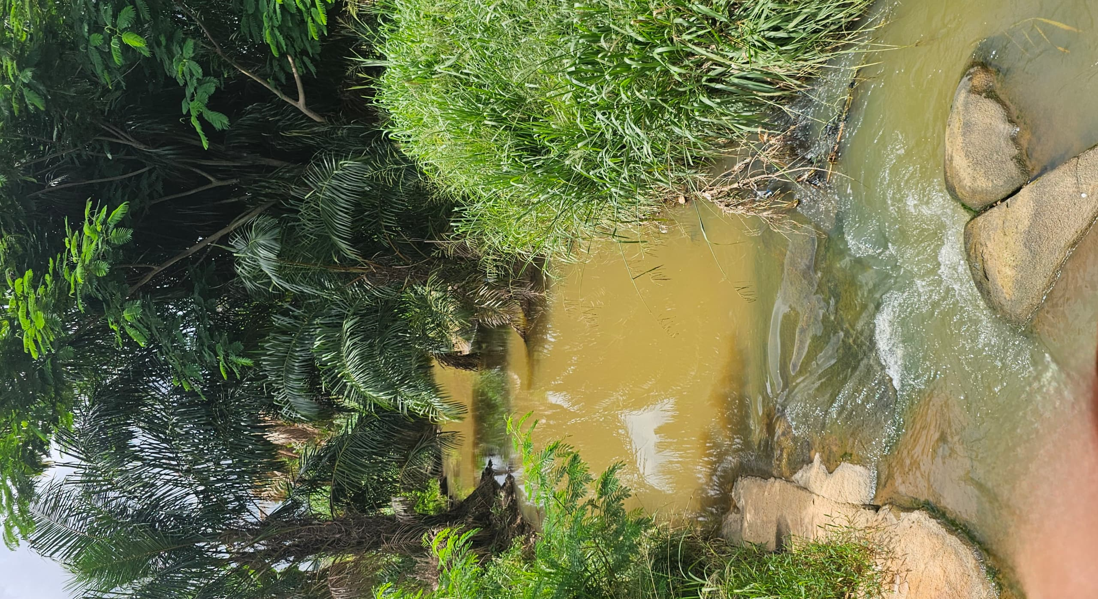

Figure 3: Midstream of river Wiwi

#### **3.4.3 Downstream**

The downstream section of the river Wiwi was taken at KNUST botanical gardens which faces pollution challenges from urban activities and agricultural practices, impacting water quality and ecosystem health. The clarity of the river is dark brown through out the seaseon as a result the fishes present are pollution tolerant. There is a lot of anthropogenic activities hence the diversity of the fishes reduced with time.There is a lot of vegetation present but no or low number of rocks were recorded. The temperature recorded was as follows; morning 29.0 º, afternoon 33.7º and evening 33.0º. The width(W) was recorded as 7.71m , length(L) 18.75m , mean depth(d) 1.04m. The area(A) was calculated as 144.56m2 ,velocity(V) was calculated three times as 0.56, 0.5499,and 0.474ms-1 and discharge (Q) as 76.62m2s-1 .

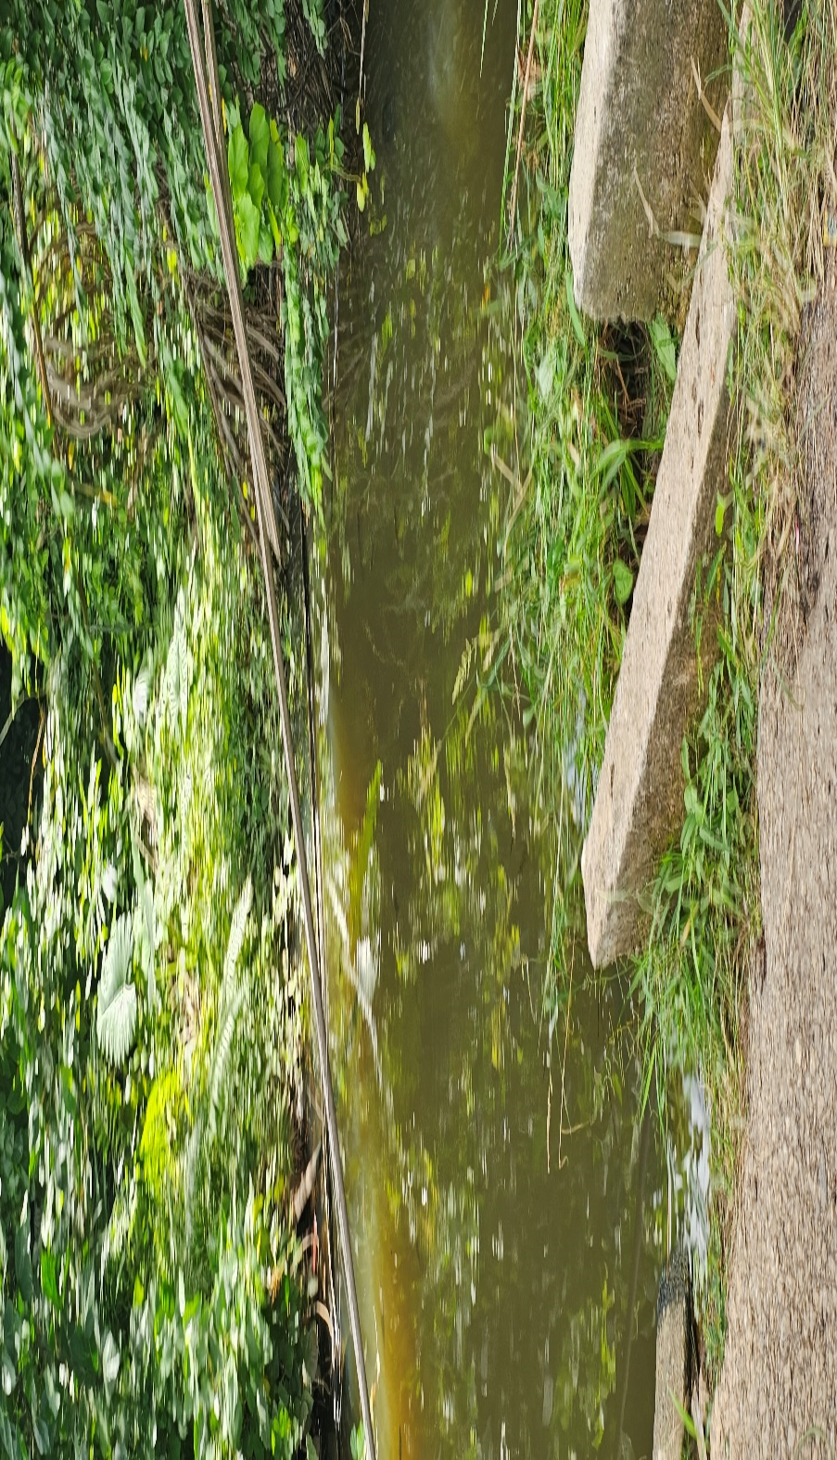

Figure 4: Downstream of River Wiwi

### **3.5 Materials and methods**

#### 3.5.1 Materials

Fishing net

Gloves

Basins

Rope

Tape measure

Thread

Mercury thermometer

#### 3.5.2 Sampling procedure

1. A reference point along the river with a very optimum flow was selected
2. A reference area was chosen along the river which had different species of fishes and had a high number of the fishes present.
3. All the needed equipments for the sampling procedures such as fishing net, gloves, basin, rope, tape measure, thread, mercury thermometer were used .
4. The selected sampling area was carefully chosen, with no or little disturbance. The particular areas to pick the samples were selected. Gloves were worn and samples were collected into the sampling container.
5. The fishing net was used to catch any type of fishes needed.
6. The important information about the sampling area were recorded including the date, time, temperature, current and other information.
7. The sampling procedure was repeated several times at each stream (upstream, midstream and downstream) of the river.
8. Basins were used to store the samples collected. The basins were tightly closed and stored in a cool, dry place.

#### 3.5.3 Physio-chemical parameters

##### 3.5.3.1 Temperature

Mercury thermometer was used to measure the temperature in degree celcius(ºC). The mercurt thermometer was dipped directly in the water to measure the surface temperature. Three measurements were taken at each stream and an average was taken ( T1+T2+T3)/3.

##### 3.5.3.2 Current

The current was checked via direct observation of the river.

##### 3.5.3.3 Water depth

###### 3.5.3.3.1 Materials

Rope, tape measure, permanent maker pen and stone.

###### 3.5.3.3.2 Procedure

A reference point was selected at the middle of the sampling area (upstream, midstream and downstream. The rope was attached to the stone. The middle of each stream was divided into three equal parts. For the first part, the stone that was tied to the rope was dipped into the river until it hit the bottom.

The stone attached to the rope was removed and the permanent marker was used to mark the wet part of the rope as a reference point. The tape measure was used to take the measurement of the depth from the reference point on the rope to the end of the stone. The process was repeated at each part of the stream and an average of the depth at each site were determined. The same procedure was repeated three times at the various stream of the river.

##### 3.5.3.4 Velocity

###### 3.5.3.4.1 Materials

Tape measure, stop clock and floating object

###### 3.5.3.4.2 Procedure

Float method was used to measure the velocity of the river at each sampling site. A known distance was determined along the direction of the flowing river. A distance was measured using sticks, stick X and stick Y and recorded as XY. The floating object was dropped at stick X, the time was recorded from stick X and stopped at stick Y. The time taken for X to reach Y was recorded with a stop clock. The velocity was then calculated by the formula;

Velocity = Distance between stick X and Y (m)/ Time (s).

This process was repeated three times for each stream and average was determined.

##### 3.5.3.5 Water discharge

The velocity and area of the river was multiplied to determine the amount of water that passes through each sampling area. The discharge was determined by the formula;

Discharge(Q) = Velocity × Area

##### 3.5.3.6 Water color

This was determined via visual observation that is colourless , muddy , brownish and cloudy

PREAMABLE: A device called Hackman multi-parameter probe was used to check for the conductivity, dissolved oxygen (DO) and PH .  Different procedure or method was used depending on the parameter that was been measured at that particular time.

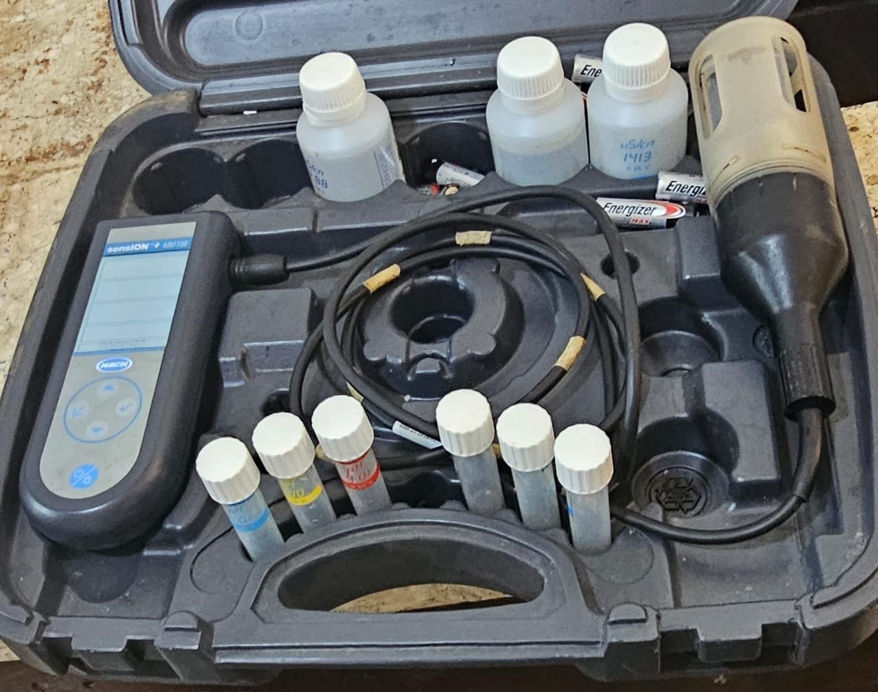

Figure 5: Hackman multi-parameter probe

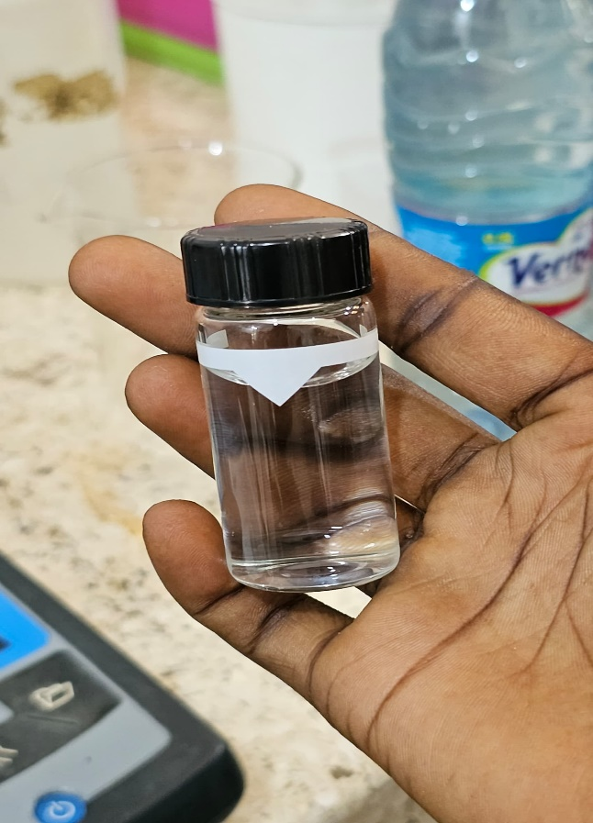

Figure 6: The turbidimeter reading flask

##### 3.5.3.7Turbidity

Portable turbidimeter was used. Turbidimeter reading flask or sample cell with distilled water inside was used . The turbidity reading flask was cleaned with an unused tissue . This is because light of a particular wavelength was used. The distilled water in the cell was used to calibrate it to get 0.00ntu. After the device was calibrated, 0.3ml samples of the river from all the various stream (upstream, midstream and downstream) was used. The Hackman multi-parameter probe was dipped into the 0.3ml of the samples in the sample cell . After the values of the various streams were recorded.

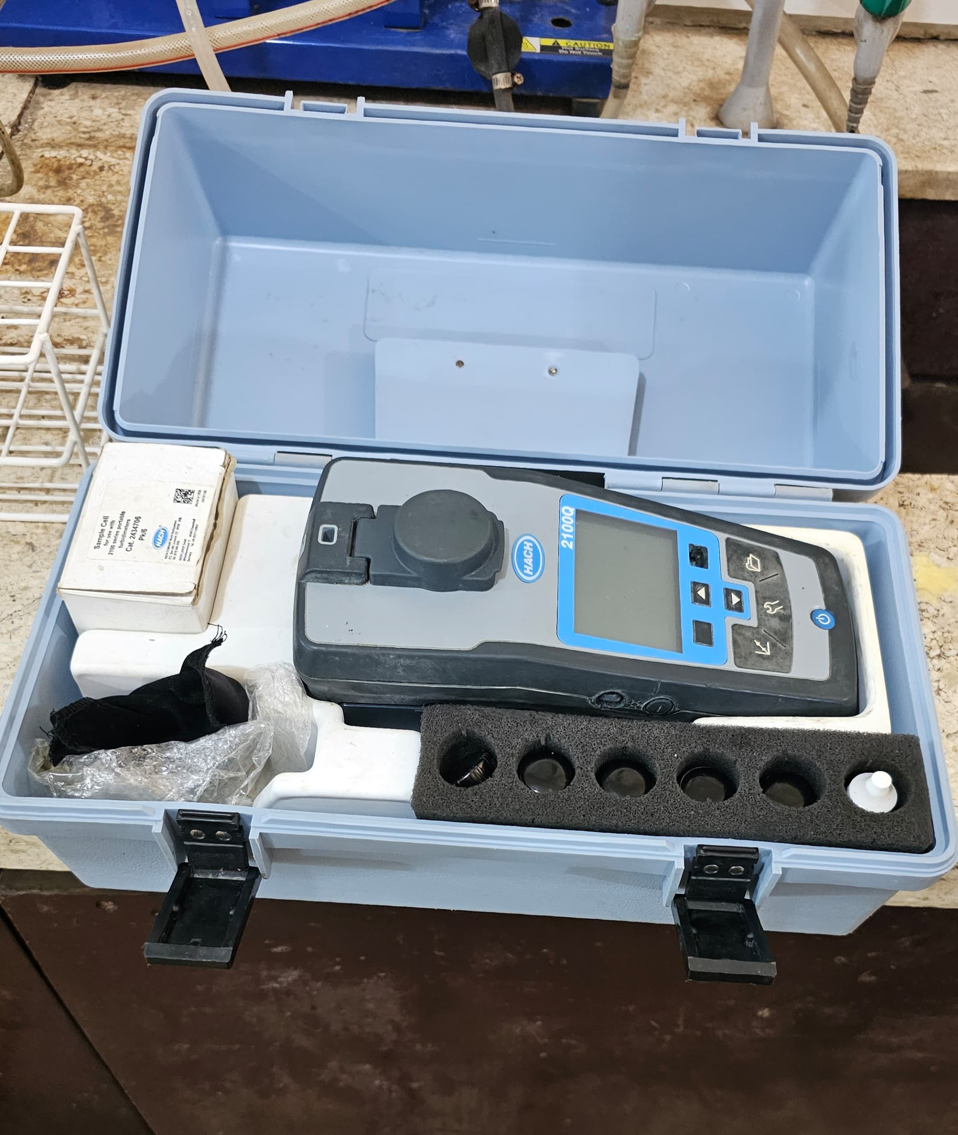

Figure 7: Portable turbidimeter

##### 3.5.3.8 Dissolved Oxygen

The Hackman multi-parameter probe was dipped inside the 0.3ml sample of all the various stream (upstream , midstream and downstream) of the river which was contained in the sample cell. It was dipped in it until the device started reading , this was done by preventing any air interference thus, all windows and fan was shut down for an accurate results. The values were recorded in percentage.

##### 3.5.3.9Conductivity

The Hackman multi-parameter probe was dipped inside the 0.3ml sample of all the various stream (upstream , midstream and downstream) of the river which was contained in the sample cell. It was dipped in it until the device started reading , this was done by preventing any air interference thus, all windows and fan was shut down for an accurate results. The values were recorded in percentage.

##### 3.5.3.10 Hydrogen ion concentration (Ph)

The Hackman multi-parameter probe was dipped inside the 0.3ml sample of all the various stream (upstream , midstream and downstream) of the river which was contained in the sample cell. It was dipped in it until the device started reading , this was done by preventing any air interference thus, all windows and fan was shut down for an accurate results. The values were recorded in percentage.

##### 3.5.3.11 Total nitrate and phosphate

The amount was total nitrate and phosphate were measured, which serves as the nutrients in the river. High amount can lead to hypertrophication whilst low amount can lead to eutrophication .

###### PREAMBLE

Spectrophotometer was used to check for the amount of nutrients present in the river, specifically the amount of nitrate and phosphate. This device works on the principle of wavelength , hence specific wavelength was used depending on the nutrient of interest. A cuvette which contained distilled water was used to calibrate the spectrophotometer, and the calibration value was read as 0.00

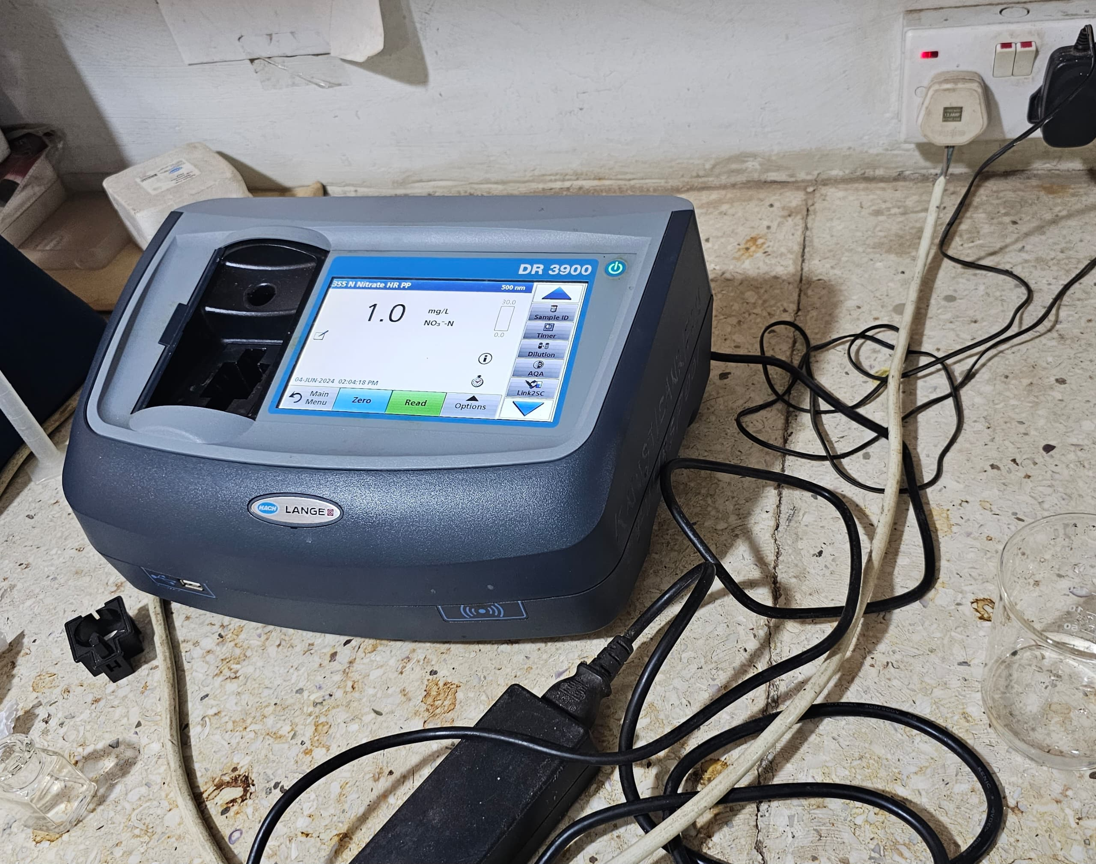

Figure 8: A spectrophotometer

###### 3.5.3.11.1 Total nitrate

2.0ml of the river sample from all the various streams(upstream, midstream and downstream) was placed in a measuring flask. After this, 8.0ml of distilled water was added to the 2.0ml of the river sample in the measuring flask. A nitrate pillow, a chemical used to detect for the presence of nitrate was added to the solution in the measuring flask. The sample was allowed to settled and waited for 5 minutes. A wavelength of 500nm was set on the spectrophotometer and the readings



Figure 9: Nitrate pillows

###### 3.5.3.11.2 Total phosphate

2.0ml of the river sample from all the various streams(upstream, midstream and downstream) was placed in a measuring flask. After this, 8.0ml of distilled water was added to the 2.0ml of the river sample in the measuring flask. A nitrate pillow, a chemical used to detect for the presence of nitrate was added to the solution in the measuring flask. The sample was allowed to settled and waited for 3 minutes. A wavelength of 880nm was set on the spectrophotometer and the readings were recorded.

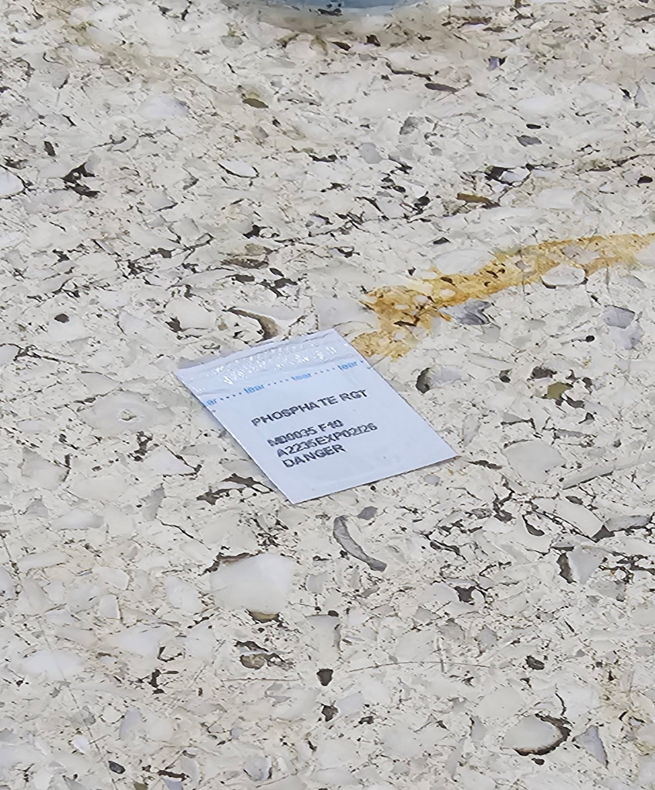

Figure 10: Phosphate pillow

##### 3.5.3.12 Fish diversity and distribution

Method of collection.

A fishing net was used to catch the various fishes species at Abirem, Wiwiso and KNUST botanical gardens. Different species of fishes are adapted to various habitat in the river. Certain fishes have the ability to camouflage with the environment which made it difficult to identify them. Others too have the ability to hide under the soil and rocks as a form of protection against potential predators. The shape of the caudal fin gave some species a higher advantage over others since forked shaped fishes are very fast. With all this adaptations, quite a significant amount of some fish species were collected by throwing the net over the river. Large variety of fish species were not found due to overfishing and construction of infrastructures such as dams, bridges farming, etc. Certain species too were known to be extinct over the years. Because our focus is on the distribution and diversity of fishes, the fishes collected were counted, measured and recorded. After collection, the fishes were given to the people in the community to feed on. The last collection of fishes of the various streams were thrown back into the river. This was done to continue and conserve biodiversity. No chemicals were used to extract the fishes from the river. Whilst fishing, the various habitat of the different species of fishes were identified.

### **3.6 Data analysis**

The data analysis was performed using Microsoft excel spreadsheet and the software used was Analysis Of Variance(ANOVA). And the results were presented using descriptive statistics which includes graph and pie chart.

# CHAPTER FOUR (4)

I will add it after I am done with the analysis….